**Project Design Phase-II**

**Data Flow Diagram & User Stories**

|  |  |
| --- | --- |
| Date | 03 October 2022 |
| Team ID | PNT2022TMID35651 |
| Project Name | Project - Smart Lender - Applicant Credibility Prediction for Loan Approval |
| Maximum Marks | 4 Marks |

**Data Flow Diagrams:**

A Data Flow Diagram (DFD) is a traditional visual representation of the information flows within a system. A neat and clear DFD can depict the right amount of the system requirement graphically. It shows how data enters and leaves the system, what changes the information, and where data is stored.

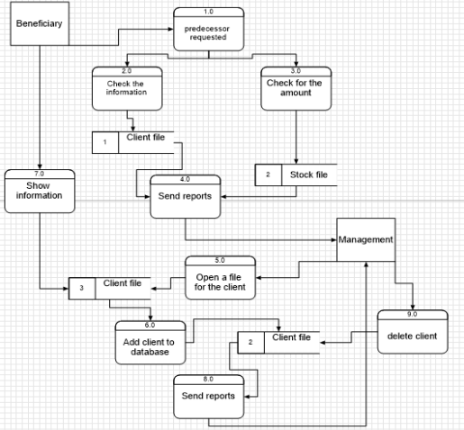

**User Stories**

Use the below template to list all the user stories for the product.

| **User Type** | **Functional Requirement (Epic)** | **User Story Number** | **User Story / Task** | **Acceptance criteria** | **Priority** | **Release** |
| --- | --- | --- | --- | --- | --- | --- |
| Customer (Mobile user) | Registration | USN-1 | As a user, I can register for the application by entering my email, password, and confirming my password. | I can access my account / dashboard | High | Sprint-1 |
|  |  | USN-2 | As a user, I will receive confirmation email once I have registered for the application | I can receive confirmation email & click confirm | High | Sprint-1 |
|  |  | USN-3 | As a user, I can register for the application through Facebook | I can register & access the dashboard with Facebook Login | Low | Sprint-1 |
|  |  | USN-4 | As a user, I can register for the application through Gmail | I can receive confirmation email & click confirm | Medium | Sprint-1 |
|  | Login | USN-5 | As a user, I can log into the application by entering email & password | Able to login | High | Sprint-1 |
|  | Dashboard | USN-6 | As a user, I should be able to access the dashboard with everything I am allowed to use. | Access the dashboard | Medium | Sprint-1 |
| Customer (Web user) | Registration | USN-7 | As a user, I can register for the application by entering my email, password, and confirming my password. | I can access my account / dashboard | High | Sprint-1 |
|  |  | USN-8 | As a user, I will receive confirmation email once I have registered for the application | I can receive confirmation email & click confirm | High | Sprint-1 |
|  |  | USN-9 | As a user, I can register for the application through Facebook | I can register & access the dashboard with Facebook Login | Low | Sprint-1 |
|  |  | USN-10 | As a user, I can register for the application through Gmail | I can receive confirmation email & click confirm | Medium | Sprint-1 |
|  | Login | USN-11 | As a user, I can log into the application by entering email & password | Able to login | High | Sprint-1 |
|  | Dashboard | USN-12 | As a user, I should be able to access the dashboard with everything I am allowed to use. | Access the dashboard | Medium | Sprint-1 |
| Loan Approval Officer | Register | USN-13 | As a loan approval officer, I should be able to register myself as one using unique email and password. | I can access my account | Medium | Sprint-2 |
|  | Login | USN-14 | As a loan approval officer I should be able to login myself as one using unique email and password. | Access loan approval dashboard | Medium | Sprint-2 |
|  | Automated analysis of credit history | USN-15 | As a loan approval officer, I can access the dashboard where I feed application for loan prediction. | I can access the dashboard for loan application prediction. | High | Sprint-3 |
|  |  | USN-16 | As a loan approval officer, I can get a decision followed by some details for the decision when I feed an application for loan prediction. | Get a decision for loan prediction with details regarding the decision. | High | Sprint-3 |
| Admin | Register | USN-17 | As an admin, I should be able to register myself as one using unique email and password. | I can access my account | Medium | Sprint-4 |
|  | Login | USN-18 | As an admin I should be able to login myself as one using unique email and password. | Able to login | Medium | Sprint-4 |
|  | Dashboard | USN-19 | As a admin, I should be able to access the dashboard with everything I am allowed to use. | Access the dashboard | Medium | Sprint-4 |